N.SURYA TEJESWAR REDDY
CB.SC.U4CSE23127
CSE-B
SET-1
2nd Question

test> use BillDetails
switched to db BillDetails
BillDetails> db.bills.insertOne({
... billno: "B101",
... vendor: "xyz",
... date: "11-aug-2025",
... quantity: 50
... })
{
acknowledged: true,
insertedId: ObjectId('696a4a533f24d958b51e2621')
}
BillDetails> db.bills.insertOne({
... billno: "B101",
... vendor: "xyz",
... date: "12-aug-2025",
... quantity: 150
... })
{
acknowledged: true,
insertedId: ObjectId('696a4a5b3f24d958b51e2622')
}
BillDetails> db.bills.insertOne({
... billno: "B102",
... vendor: "xy",
... date: "13-aug-2025",
... quantity: 50
... })
{
acknowledged: true,
insertedId: ObjectId('696a4a623f24d958b51e2623')
}
BillDetails> db.bills.find({ billno: "B102" })
[
{
_id: ObjectId('696a4a623f24d958b51e2623'),
billno: 'B102',
vendor: 'xy',
date: '13-aug-2025',
quantity: 50
}
]
BillDetails> db.bills.updateOne(
... { billno: "B101", date: "11-aug-2025" },
... { $set: { date: "13-aug-2025", quantity: 150 } }
... )
{
acknowledged: true,
insertedId: null,
matchedCount: 1,
modifiedCount: 1,
upsertedCount: 0
}
BillDetails> db.bills.deleteMany({ billno: "B101" })
{ acknowledged: true, deletedCount: 2 }
BillDetails> db.bills.find({ billno: "B101" })

Outputs:
a.Create a Database for storing BillDetails
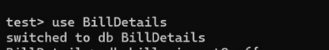

b. (i)create a MongodDB document with billno:B101,vendor:xyz, date:'11-aug-2025', quantity:50
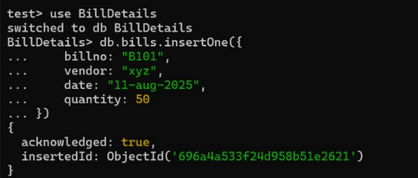

(ii)create a MongodDB document with billno:B101,vendor:xyz, date:'12-aug-2025', quantity:150
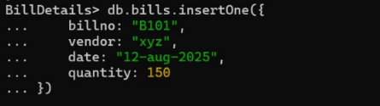
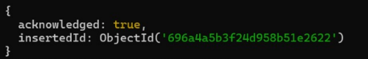

(iii)create a MongodDB document with billno:B102,vendor:xy, 3 date:'13-aug-2025',quantity:50
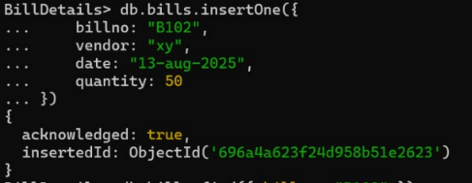

c.search for the document whose billno is B102
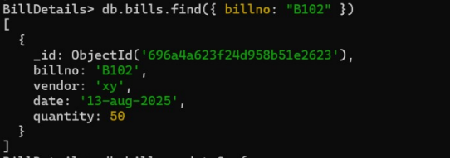

d.Update the document whose billno is B101 and date as '11-Aug-2025' as billno:B101,vendor:xyz, date:'13-aug-2025',quantity:150
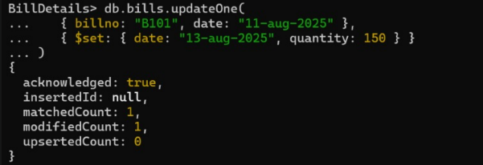
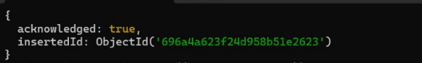
e.Remove the document whose Billno is B101
